
National Council for Persons with Disabilities
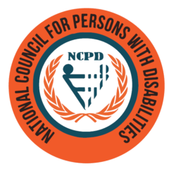
ANNUAL REPORT
AUGUST 2019 - JULY 2020
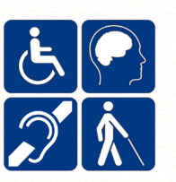

Contents
3
CHAIRPERSON STATEMENT 3
EXECUTIVE DIRECTOR’S REMARKS 2
Organisation Overview 3
Definition 3
Vision Error! Bookmark not defined.
Mission Statement Error! Bookmark not defined.
Organisation Structure Error! Bookmark not defined.
Members Of the Council For Persons With Disabilities 6
Registered Services 6
NCPD Affiliates 6
1. Council Meetings 8
2. Advisory & District Committees 8
Conclusion 19
Contact Us 21

CHAIRPERSON STATEMENT
It is with great pride and gratitude that I present the National Council for Persons with Disabilities (NCPD) 2019/2020 Annual Report. This year has been a transformative period for the Council, marked by significant achievements, strengthened partnerships, and collective progress in advancing the rights and well-being of persons with disabilities in Fiji.

Achievements
The NCPD has made remarkable strides in promoting inclusivity and accessibility for persons with disabilities across various sectors. Among our key accomplishments this year:

- Policy and Legislative Advancements – The Council has actively engaged in advocating for policy reforms and legal frameworks that uphold the rights of persons with disabilities, aligning with the United Nations Convention on the Rights of Persons with Disabilities (UNCRPD) and the Rights of Persons with Disability Act, 2018.
- Capacity Building and Empowerment – Together with our affiliates and partners, we successfully conducted training and awareness programs aimed at empowering persons with disabilities, their families, and caregivers, equipping them with the necessary skills to advocate for their rights.
- Enhanced Collaboration – We continued to strengthen ties with government ministries, development partners, and stakeholders have led to more inclusive programs and services.
Opportunities and Challenges
While we celebrate our successes, we acknowledge that challenges remain. The ongoing need for more inclusive infrastructure, greater public awareness, and sustained funding continue to be areas requiring attention. The COVID-19 pandemic also posted significant hurdles, affecting program implementation and the provision of essential services.
However, these challenges present opportunities for innovation, resilience, and stronger collaboration. Through adaptive strategies and commitment from all stakeholders, the NCPD has been able to navigate these obstacles and ensure that no one is left behind.

A Year of Successful Collaboration
The NCPD’s achievements would not have been possible without the unwavering support of the Fijian Government, development partners, affiliates, and various stakeholders. The collaboration with government ministries has enhanced service delivery, while our partnerships with non-governmental organizations and international agencies have provided critical resources and technical support.
We extend our heartfelt gratitude to all our partners and supporters for their dedication to the disability movement in Fiji. Together, we continue to break barriers and create an inclusive society where persons with disabilities are empowered to thrive.

Conclusion
As we reflect on the progress made in 2019/2020, we look forward to building on these foundations to further strengthen disability rights, accessibility, and opportunities for persons with disabilities. The NCPD remains committed to its vision of an inclusive Fiji, and we will continue working tirelessly towards this goal.
Thank you all for your support and commitment to making a meaningful difference in the lives of persons with disabilities.
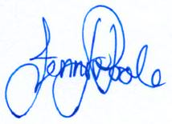

Jennifer Poole
Chairperson
National Council for Persons with Disabilities

EXECUTIVE DIRECTOR’S REMARKS

It is with great pride and gratitude that I present the National Council for Persons with Disabilities’ Annual Report for the 2019/2020 financial year. This report highlights our unwavering commitment to advancing the rights, inclusion, and well-being of persons with disabilities across the nation.

Despite the challenges faced, including the global impact of the COVID-19 pandemic, we have made significant strides in policy advocacy, capacity building, economic empowerment, and ‘w0accessibility improvements. Our programs and initiatives have been driven by the guiding principle of ensuring equal opportunities and dignity for all persons with disabilities.

I extend my deepest appreciation to our stakeholders, government agencies, development partners, and most importantly the disability community (OPDs), whose resilience and determination continue to inspire our work. The collaboration and dedication demonstrated throughout this period have been instrumental in our achievements.

As we move forward, we remain steadfast in our mission to create an inclusive society where persons with disabilities can fully participate and thrive. We reaffirm our commitment to strengthening policies, enhancing service delivery, and fostering a more accessible and equitable future for all.

Thank you for your continued support.


Roneel Saxena
Acting Executive Director
National Council for Persons with Disabilities

Organisation Overview
The NATIONAL COUNCIL FOR PERSONS WITH DISABILITIES (NCPD) has been in existence since 1993 and was enacted by Parliament in December 1994. This followed on from meetings held in Manila in April 1992 and Beijing in October 1992 regarding persons with disabilities reinforcing the development already taking place in Fiji for the establishment of a National Coordination mechanism.

In 1993, Fiji became a signatory to "Beijing Proclamation" on the Agenda for Action concerning the Asian and Pacific Decade of Disabled Persons. 1993 — 2002, and used the framework of this instrument in developing the FNCPD Act 21 of 1994.

In October 2001, United Nations Economic and Social Commission for Asia and the Pacific (UNESCAP) held a high-level Inter-government meeting to conclude the Asian and Pacific Decade of Disabled Persons, in Outso City, Japan. It was at this meeting that UNESCAP adopted resolution 85/4/of 22 May 2002 and proclaimed the extension of the Asian and Pacific Decade of Disabled Persons for another decade, 2003 — 2012. The Biwako Millennium Framework for Action (BMF), and the United Nations Convention on the Rights of Persons with Disabilities (UNCRPD) and its optional protocol was adopted in December 2006 and open for signatures on 30th March 2007and came into effect from May 2008, was signed by Fiji on the 2nd of June 2010, which provides valuable guidelines to National and Regional Governments and relevant stakeholders groups in promoting an inclusive, barrier-free and rights-based society for people with disabilities in the Asian and Pacific region.

Towards the end of 2012, Fiji signed a new framework for the new Decade of Action for Asia Pacific Region for 2013 — 2022.Since it was signed in Incheon, Korea thus it was called the Incheon Strategy (2013 — 2022) with the overarching theme of "Making the Right Real".
Fiji is also a signatory to the Sendai Framework for Disaster Risk Reduction 2015 - 2030.
Fiji Ratified the United Nation Convention on the Rights of Persons with Disabilities on the 9th June 2017.

The Fiji National Council for Disabled Persons Act 1994 is now repealed.
The Name of the Organization on record was removed and re-entered to the Register as NATIONAL COUNCIL FOR PERSONS WITH DISABILITIES
On the 12th day of March 2018 Parliament of the Republic of Fiji enacted "Rights of Persons with Disabilities Act 2018 (Act No. 4 of 2018)
Which gives establishment of the National Council for Persons with Disabilities its roles and functions and how to make provisions for the Protection of the Rights of Persons with Disabilities in Accordance with the United Nations Convention on the Rights of Persons with Disabilities and for related matters?

Definition

Persons with Disabilities includes those who have long-term physical, mental, intellectual or sensory impairments which in interaction with various barriers may hinder their full and effective participation in society on an equal basis with others;

VISION

We Envisioned an Empowered Person With Disabilities And Ensuring A Barrier Free And Inclusive Society For All.

MISSION STATEMENT

- Facilitate the process of creating a barrier free Society through a collective collaboration and partnership with all stakeholders.
- Bring to prevail for persons with disabilities in Fiji a situation whereby government ministries and statutory authorities, local government, corporate sector, and civil society organizations meet their legislative, constitutional and international convention obligation.
- 0rganize and continue to strengthen National affiliates through democratic, gender balanced, cross-disability based processes.
- Partner with other relevant development agencies and Government Ministries towards the equalization of opportunities and full Participation of persons with disabilities in their own development and development of other community's partnership with Government ministries, civil societies and corporate entities to create a fully inclusive society.

Organisation Structure

The Council through the Chairperson reports to the Minister for Women, Children and Poverty Alleviation on all policy matters pertaining to the role and functions of NCPD. The Minister also appoints the board members of the Council from relevant Government Ministries and up to five disability organizations. This is the main decision and policy -making arm of NCPD.
The Council is assisted by Advisory Committees, members of which are nominated by the Council and appointed by the Minister responsible for Disability Development, MWCPA The roles and functions of these Committees which are stipulated under section 2(12) of the RIGHT OF Persons with Disabilities Act 2018 (act no 4 of 2018) Act is primarily to advise, examine and recommend activities under their responsibilities and to assist in the implementation of projects and research undertaken by NCPD.

At the grassroots level, there are District Committees of the Council are nominated by the Council and appointed by the Minister. These committees closely monitor the disability issues and work in collaboration with civil society organizations and other arms of Government ^{u} in addressing the plights of persons with disabilities including provision of Services and their welfare. This vital link between the Council and persons with disabilities who live in villages, settlements, remote areas and outlying islands is maintained through regular meetings of such Committees with ongoing consultation and support from the Headquarters. The leadership of District Officers and secretarial support from Social Welfare Officers in places where NCPD District Committees are formed must be acknowledged and appreciated.
The administrative and coordinating functions of the Council are handled by the Executive Director who heads the organization. Other officers recruited by the Council as well as volunteers who willingly contribute their time, skills and knowledge play a significant role in realizing and advancing the Council's vision, mission, goals, plans and program's.
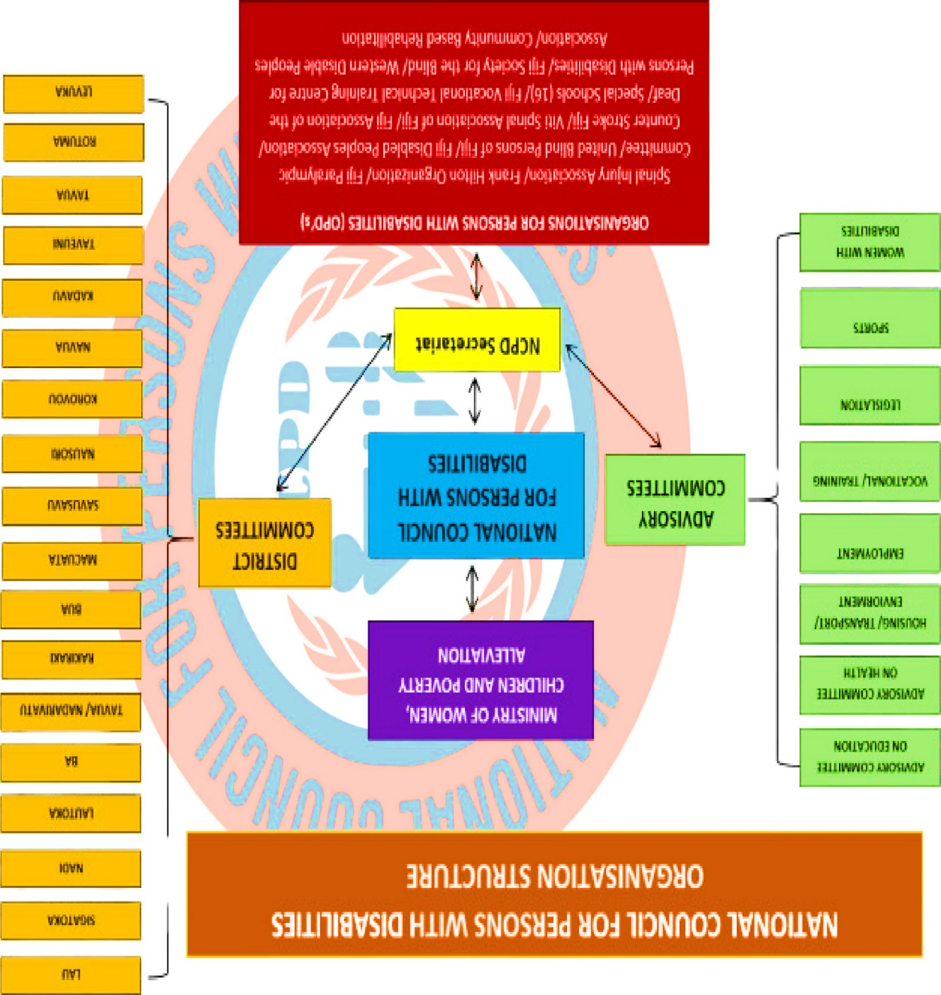
A diagrammatic representation of the organization structure of the National Council for Persons with Disabilities is given on the next page.

Members Of the Council for Persons With Disabilities
In exercising of the powers conferred upon the Minister for Women, Children and Poverty Alleviation by section 7(k) of the Rights of Persons with Disabilities Act 2018, appointment of the following
A MEMBER OF THE COUNCIL APPOINTED BY THE MINISTER UNDER SECTION 7 (K) HOLDS OFFICE FOR A TERM OF 3 YEARS AND IS ELIGIBLE FOR REAPPOINTMENT.

Registered Services
The Council's function is to register all agencies that provide services on behalf of Persons with Disabilities. They remain the major providers of services to persons with disabilities in Fiji. As a statutory authority, NCPD has a role of communicating the needs of these organizations to government ministries and coordinating developments.
A total of 35 disability organizations have now been registered with the Council. Information has been requested from thscial schools throughout the country which are managed by registered non-governmental organizations with annual financial support from both the Ministry of Education and Department of Social Welfare. Also, disabled persons organizations continued to play an important role in advocating for the rights, dignity and recognition of persons with disabilities. Similarly, disability-related programmes such as the CBR Programme under the Ministry of Health, and Project are included in this registration

NCPD AFFILIATES

SERVICE PROVIDERS | OPDS | SPECIAL SCHOOLS
Counterstroke Fiji | Fiji Paralympics Committee | Fiji Vocational Training  Centre for Persons with Disabilities
Community  Rehabilitation  Programme | Fiji Association for the Deaf | Fiji Society For The Blind
Fiji Red Cross Society | Psychiatric Survivors Association | Suva Society for the  Intellectual  Handicapped
Frank Hilton Organisation | Spinal Injury Association | Nausori Special School
Fiji Crippled Children Society | United Blind Persons Association | Ba Special School
Project Heaven | Fiji Disabled Peoples  Federation (FDPF) | Sigatoka Special School
Veilomani Boys Home | Central/Eastern  Association of the Deaf | Lautoka Special School
Western Disabled Person  Association | Tavua Welfare Society | Nadi Special School
Viti Spinal Injuries Association | Horeb Ministry | Gospel School For the Deaf
Medical Services Pacific | Deaf Harland Ministry | Levuka Society for The  Intellectually  Handicapped

SERVICE PROVIDERS | OPDs | SPECIAL SCHOOLS
Special Olympics |  | Ra Society For The Disabled
Lupus Foundation Fiji Council of Special.  & Inclusive Educators  (FCOSIE) |  | Savusavu Special School
Foundation of the  Education of the Needy Children in Fiji (FENC) |  | Labasa Special School
New Vision Fiji

1. Council Meetings

A. Advisory Committee on Employment.
- Discussions have been made on the 2% quota given to employers in employing persons with disabilities and the 400% tax rebate incentive provided by the government.
- The secretariat has been liaising with FBOS, MOE and MWCPA on the data to create a platform for the employment committee to deliberate on the employment opportunities of persons with disabilities.
- The Ministry of Employment is assisting the Council in setting up its data system by providing technical support in terms of IT personnel. This will be materialized when our Database officer is recruited next month. The collaboration will assist in the employment data space for persons with disabilities.
- Liaise with the National Employment Centre on the opportunity for persons with disabilities to be included under

B. Advisory Committee on Women
- Advocate for women with disabilities-to, be part of the any National Policy consultation
- Terms of Reference has been finalized and endorsed.

C. Advisory Committee On Education
- Work with the Ministry of Education on the Special Inclusive Education Policy which now has been completed.
- Work with the Ministry of Education on other inclusive education issues for students with disabilities.

D. Advisory Committee On Vocational Training
- Work with the Ministry of Education on the curriculum for FVTTCPD (still in progress)
- Collaborate with APTC on the improvement of the school programs. (In progress)
- Currently working with the Fiji Higher Education in the recognition and registration of vocational programs

E. Advisory Committee On Legislations
- Review of legislations like National Disability Policy, Implementation Plan and Strategic Plan.
- Work on other legislations in the relevant Ministries to be disability inclusive.
- Develop its term of reference

2. Advisory & District Committees

A. Advisory Committee On Employment.
- Discussions have been made on the 2% quota given to employers in employing persons with disabilities and the 400% tax rebate incentive provided by the government.
- The secretariat has been liaising with FBOS, MOE and MWCPA on the data to create a platform for the employment committee to deliberate on the employment opportunities of persons with disabilities.
- The Ministry of Employment is assisting the Council in setting up its data system by providing technical support in terms of IT personnel. This will be materialized when our Database officer is recruited next month. The collaboration will assist in the em loyment data space for persons with disabilities.
- Liaise with the National Employment Centre on the opportunity for persons with disabilities to be included under

B. Advisory Committee On Women
- Advocate for women with disabilities to be part of the any National Policy consultation
- Terms of Reference has been finalized and endorsed.

C. Advisory Committee On Education
- Work with the Ministry of Education on the Special Inclusive Education Policy which now has been completed.
- Work with the Ministry of Education on other inclusive education issues for students with disabilities.

D. Advisory Committee On Vocational Training
- Work with the Ministry of Education on the curriculum for FVTTCPD (still in progress)
- Collaborate with APTC on the improvement of the school programs. (In progress)
- Currently working with the Fiji Higher Education in the recognition and registration of vocational programs

E. Advisory Committee On Legislations
- Review of legislations like National Disability Policy, Implementation Plan and Strategic Plan.
- Work on other legislations in the relevant Ministries to be disability inclusive.
- Develop its term of reference

F. Advisory Committee on Health
- Rehabilitation programs for persons with disabilities.
- Establishment of an organization for Albinism
- Other health issues relation to disabilities

G. Advisory Committee on Sports
- Work with the Fiji Sports Council and Respective Town Council for the accessible sports facilities in Fiji.
- Support the Paralympics Association and Special Olympics Association in the provision of pathways for our- children and persons with disabilities in sports.
- Identifying potential sports personnel for special Olympic and paralympic.

H. Advisory Committee on Housing/Transport & Environment
- This Committee did not sit for the year but the Council continues to liaise with relevant stakeholders in terms of accessibility.
- Accessible Audit Team has been set up with the assistance of PDF and OPDs.
- Liaise with LTA on the accessible bus provisions.
- District Committees have started their meetings after the lifting of COVID 19 restrictions
- This includes Bua, Macuata, Savusavu, Sigatoka, Nadi, Lautoka, Ba, Tavua, Rakiraki & Kadavu. Kadavu and Ovalau was conducted in the 2nd quarter.
- Discussions on the District committees focuses on their work plans, Terms of Reference (TOR) and how best they can coordinate in serving the disability sector in their respective districts.
- The pathways must be very clear and the establishment of committees and OPDs in the district must be strengthened.

3. Implementation Plan
The awareness and re-alignment of our Implementation Plan was the main focus for these quarters. The ten (10) objectives on the Implementation Plan were re-visited since most of the activities were put on hold due to the national restrictions during the COVID 19 period.
As we on the 5th year of the Implementation Plan, our service providers, the respective OPDs, other statutory bodies, international and regional bodies and the government work tirelessly with the Council towards fulling and achieving its activities.

4. Key Highlights

4.1. Training
Short courses are designed coordinated from Ministry of Youth and Sports such as: Changing Trash to Treasure and Inclusive Sewing Training. Most of our trainees have gone, through Special Education and Mainstreams schools. Basically, this js why this typical kind of Centre - the NCPD North is being set up to support Youth with Disabilities. And we are fortunate that we have a good management who have planned and designed program to suit each individual that can create self- employment for Persons with Disabilities.
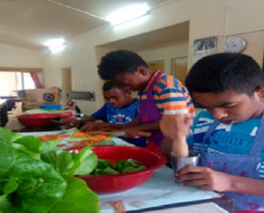
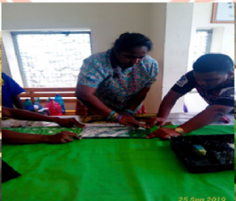
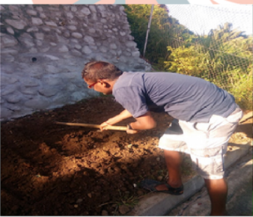

4.2 Market Day
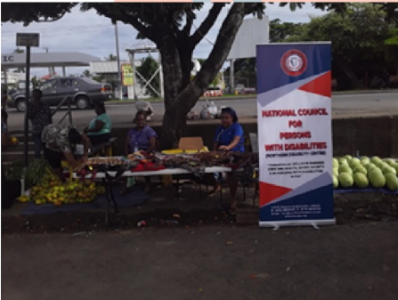
The Northern Disability Centre takes the complete product from the centre for marketing on every Saturdays in fortnight to the Labasa Market three (3) of our staff and some of our trainees are at the market for sales from 6am till l1 am. From the sales 60% are to be deposit in those trainees account who contribution in sewing or selling of the product and the 20% are kept for Training department and 20% are deposit at on HQ account.
The objective of this program is to empower, support and encourage people with disabilities for a better and independent living together with saving for the future.
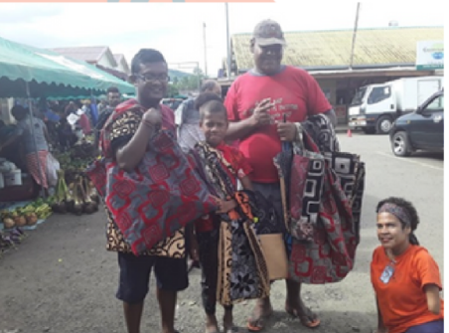
We have 6 staffs which includes Women with Disabilities, one of which is a Trainer and the other is our Clerical Officer.

Immediate Future plan is to find a hostel set up to accommodate student from far out District from the Northern (Taveuni/Bua/Savusavu & interior of Labasa). The hostel could provide Persons with Disabilities from the grass root level to be housed & trained, this could create pathways for sustainable livelihood. Within the hostel set up we plan to build it on a farm land, to increase the training & introduce Aquatic, Piggery and Poultry Farming.

4.3 Awareness
Awareness on the Rights of Persons with Disabilities and the Roles of the Council was conducted with Training Programs and District Meetings in Taveuni, Savusavu, Bua, and Labasa and also with stakeholders, namely Red Cross, Ministry of Youth, Fiji Sports Commission, Medical Services Pacific, Fiji Women's Crisis Centre, Transcend Oceania and Labasa Town Council. Also contributed and attended the Sub Regional workshop on Human Rights.

4.4 World Elder Persons Day
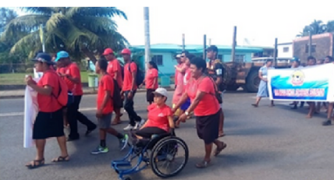
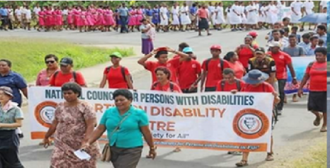
On 1st of October 2019, the world elder persons day was organized by the Golden Age Home North the NCPD was invited to be the part of the program. NCPD also participated in the March with other shareholders the program was officiated by Madam Minister, Hon. Mereseini Vuniwaqa.

4.5. Special Olympic Committees
Olympic Committee visited, the Centre to discuss on how he can include our trainees in his program. As he mentioned that Sports has changed life of persons with disabilities, and also advocated on how to keep their body healthy. He was happy to see the work trainees were doing during his visit. The center was also invited to be part of the Special Olympic Workshop that was held on 2nd November, 2019 at Labasa Special School.
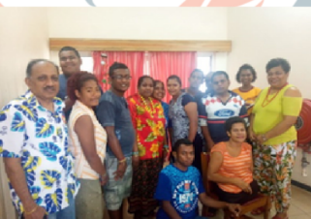
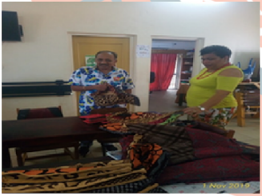
On the same day, we were invited for Special Olympics Family Forum. It was facilitated by Special Olympics Fiji. Shivangni and Ange our trainers attended this Forum Special Olympics Family Forum is sporting and advocating event for persons with intellectual disability.
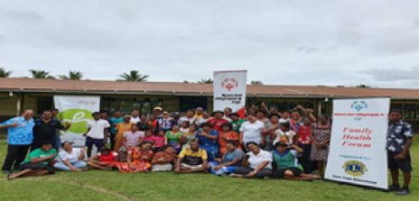
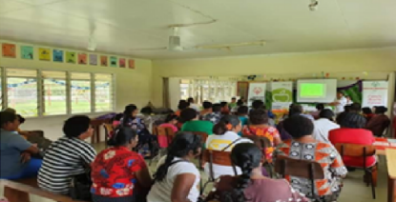

Ground Breaking Ceremony - Golden Age Home
On 14th of November 2019, the ground breaking ceremony was officiated by Madam Minister, Hon. Mereseini Vuniwaqa. The project was to upgrade the home and turn it into a modern age friendly facility for the residents. The new complex is designed to cater for 40 residents. It is a dream come true for the residents and staff who have been part of the Home for the last decade. Also present was Tui Labasa, Director Corporate and her team from Suva, Mr Jadu Ram the fonder f Old Peoples home and relevant Stakeholders.
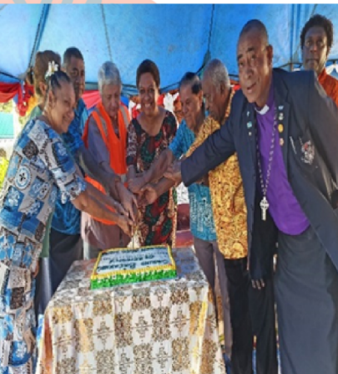
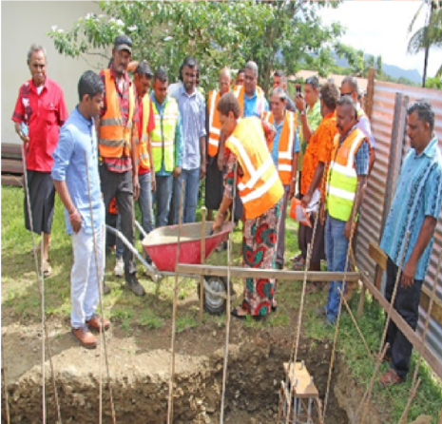

4.7 Handing Over of Badminton Set
After the successful Badminton workshop organized by Oceania Badminton and Fiji Badminton Mn Labasa on the 11th and 12th of October 2019, we were donated with full sets of Badminton equipment's including: 2 set of nets, 7 pairs racket, 5 sets of shuttles and a Victor badminton bag.
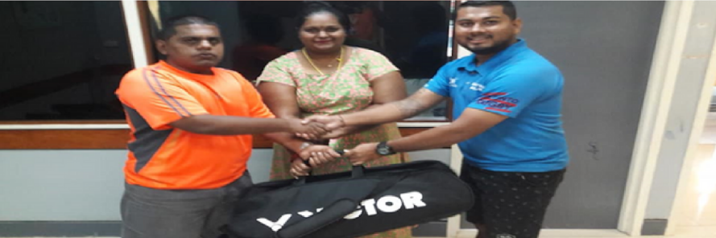

4.8 Shuttle Time Teachers Course
On 11th— 12th October 2019, we were invited for Shuttle Time Teachers Course it was facilitated by Fiji Sports Commission (Northern). Shivangni Our trainer Supervisor attend this Course. Shuttle Time Course is a coaching training program for Badminton Course.
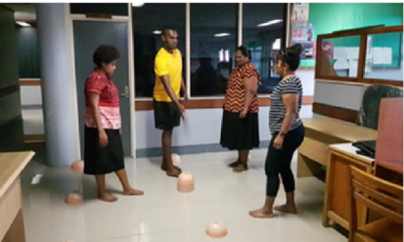
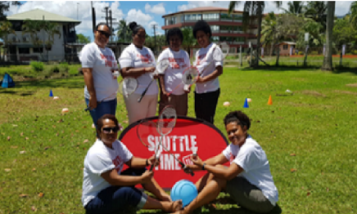

4.9 Changing Trash to Treasure Workshop
Changing Trash to Treasure workshop was 1 week program from 25th to 29thof November 2019 ^{L} it was organized by Ministry of Youth and Sports Northern Division including youths with disability from different school and youth clubs. The workshop was how to change Trash to Treasure using empty packs of bongo, soap powder and etc. On the
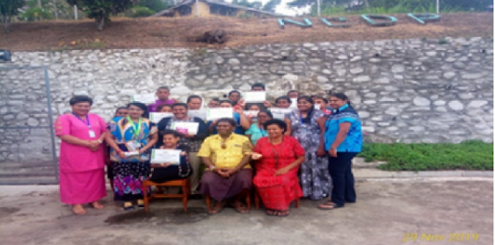
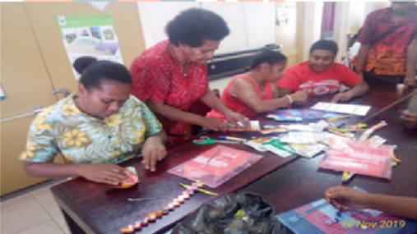

4.10 Prevention Of Child Abuse And Neglect (PCAN) Celebration
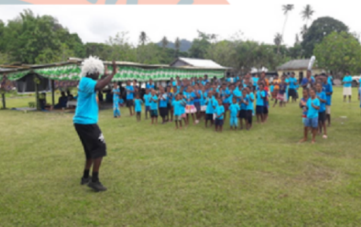
We were so fortunate to be invited to take part during the PCAN Celebration that was organized for the Tikina of Vaturova & Koroalau that was held at Vuinadi Village on the 28th of November, 2019

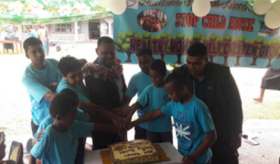
The Chief Guest for the day was the Provincial Administrator Cakaudrove Mr. Setareki Dakuiboca officially opened the program reminding us as stakeholders, teachers, coaches and as parents that children needed to be loved and protected and that they are precious gift from God. Every one present at the village took part in Zumba, Badminton, Cricket, Quick Rip Rugby and Volleyball and also organized inclusive Badminton for the Lomani Au Children's Home.

4.11 Community Awareness - Talanöa Séssion
The Talanoa Session was held in Vunivau and was conducted by Ms Monisha Rao and Ms Shivangni Rao on Thursday, 28th November 2019. The community were enlighten on the rights of persons living with disabilities, the stigma in the community, traditional beliefs are still followed such as disability curse, how to incorporate disability etiquette, for all persons with -disabilities. The communities were briefed about the Centre and the service provided,
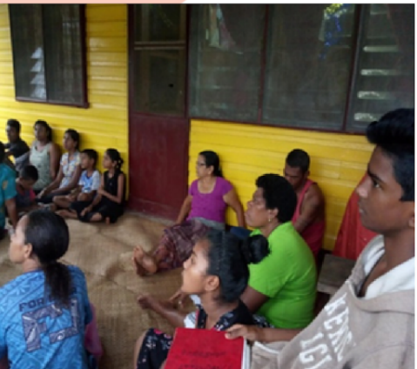
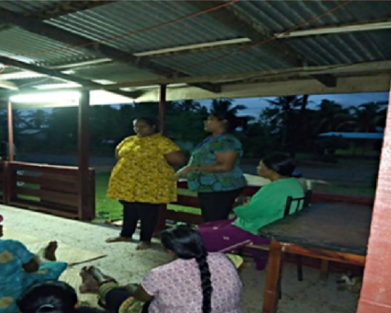

4.12 International Day for Persons With Disabilities Celebration - Taveuni
Theme: “Empowering Persons with Disabilities and Ensuring Inclusiveness and Equality"
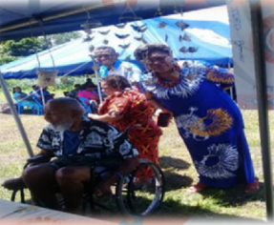
The IDPD celebration was held on 03rd December, 2019 at the Waiyevo Ground, Taveuni. The Disability Officer North and I was so fortunate to be part of the Celebration. The Chief Guest for the day was the Ms Veronika Narayan, she is a Braille transcriber by profession at the Fiji Society for the Blind. She enlightens us with her success stories, spoke on life experiences and how she became a brailleist.
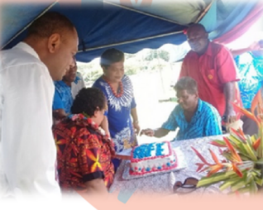
She really inspired Persons with Disabilities not to look at their disabilities but their abilities. The theme is reminding all stakeholders to work together and make difference in the lives of Persons with Disabilities. Parents and Carers shared stories on the experiences and challenges faced to look after Persons with Disabilities" but this did not deter them from supporting them. The Taveuni Disabled Persons Association also displayed Jewelry that was made by them o showcase their talents.

4.13 Economic Empowerment Training
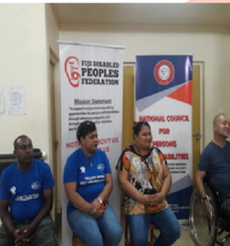
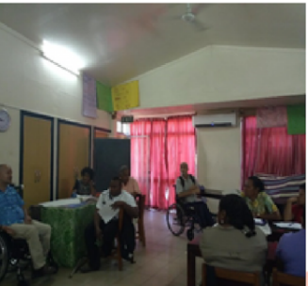
The three (3) days training program was held at the Centre for the Macuata and Bua participants and was conducted by Fiji Disabled Peoples Federation (FDPF), Ministry of Social Welfare and NCPD (HQ) from 5th to 7th of December 2019, There were sixteen persons with disabilities who participated in the training and was taught on How to plan a Business, the difference between Retail and Wholesale Business, How to calculate Profit and Loss and how to save for future use. The empowerment training was held to empower, support and encourage people with disabilities for a better and independent living together with saving for the future. was concluded with a certificate presenta ion for the participants.

4.14 16th Days of Activism Against Gender Based Violence "Orange the World”
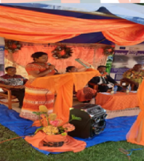
This program was organized by Empower Pacific and Ms Monisha Rao represented the Centre.
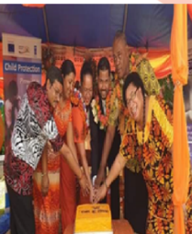
The aim fo the program was to call for holistic approach and increase awareness, galvanize advocacy efforts and share knowledge and innovations.-The protection of our Women and Girls against Violence and Rape, and as a parents we should protect our children from domestic violence, child abuse and neglect.

We should always find time out of our busy schedules to listen to their views and issues faced by them. They should not fear us but treat us as best friend. As being quoted "Silence leads to Violence" so Women and Girls are encouraged not be silent against Domestic Violence to create awareness to the public.

4.15 Visitation of Japan International Cooperation Agency (JICA)_ Resident Representative And General Secretary

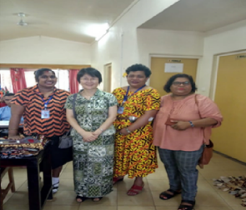
The Centre was caught by surprise for the visitation of the JICA resident representative and her team on 31st of January 2020. It was a follow up visit on the Action Plan that was done by Ms. Monisha Rao when she attended the Capacity Development of Leaders with Disabilities for UNCRPD Implementations in 2017 in Tokyo, Japan.

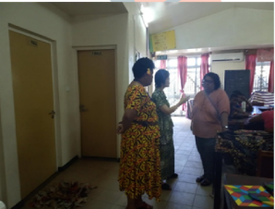
She requested for a Television Set for the Implementation of her Action Plan to show success stories to trainees for capacity development of trainees and at the same time trainees enrolled at the Centre are with intellectual disabilities and are severe autistic, for them literacy and numeracy does not work thus visualize programs are more effective to encourage and empower them and it is an ongoing program at the

4.16 JICA Sports Day
The Northern Disability Centre participated in first ever Family Fun Sports Day that was held on Saturday lst February, 2020 at the Loin Park 15 of our trainees together with 4 staff participated with Ex JICA participates and officials for the event.
The objective of this events was to have an inclusive Sports with assistances of Northern Sports Commission.
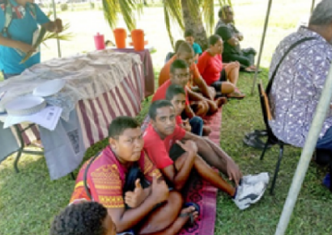
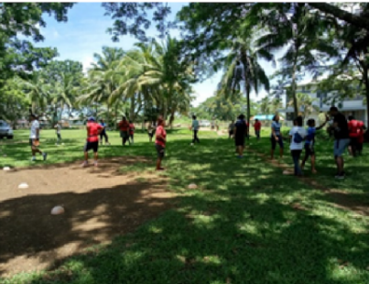

4.17 Golden Age Home - Diverse Program
Our diverse program with Golden Age Home residents stared on Wednesday 12th February, 2020 the program was led by Shivangni. This program was run every fortnight on Wednesday's and Friday. The objective of the program was to have Inclusiveness with Elders. The residents and the trainees blended in well with them.
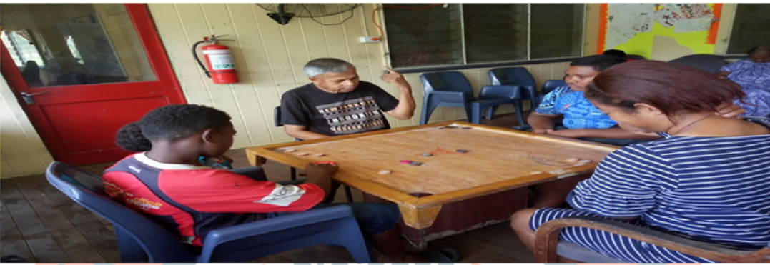

4.18 Inclusive Sewing Training
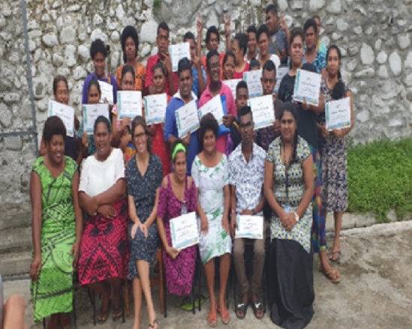
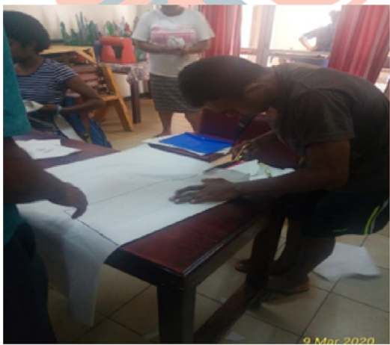
The five (5) days training program was facilitated by Ministry Youth and Sports from 9th t013thof March 2020,it was an inclusive sewing training whereby seventeen of our trainees fro the centre participated in the training with another youth group the purpose of the training was to taught on how to cut and assembly shirts, shorts and bags . We also had other stakeholder slotted in program like reproductive health, Fiji police force with legal aid to create awareness on the right of Persons with Disabilities.

4.19 Ministry of Youth and Sports Feedback Meeting
On 3rd of July 2020, we had Ministry of Youth and Sports Feedback meeting it was facilitated by Anshu Lata and the objective of the meeting was to get feedbacks on how satisfied we were, what were the issues faced during the training that Ministry of Youth and Sports has organized for youths with disability and were trainees got any kind of grant from the ministry.
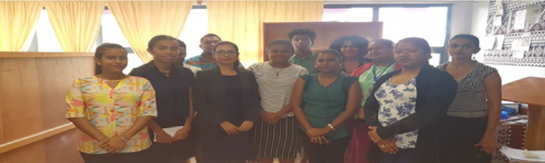

4.20 FDPF And Shifting the Power Hamper Pack Distribution
On 22nd of July 2020, we had guests at our center from FDPF and Shifting the Power to distribute the pack. Our 21 identified recipients have received the hamper. From Fhe 21 recipients. Monisha and Shivangni assisted in distribution of hamper to the community as well.
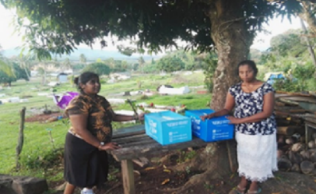
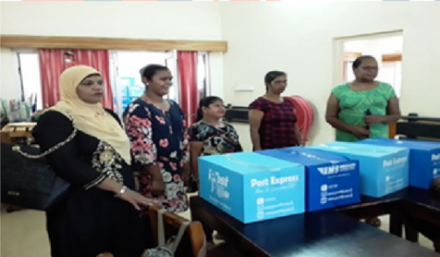

4.21 Ministry of Youth and Sports Feedback Meeting
The National Youth Policy Review was an opportunity for youth of Diverse Backgrounds to make there Submission on the New Youth Policy that will come into effect after the full endorsement of the Fiji Youth Council. For us our participation is vital as well as we have to ensure that the needs of Youth with Disabilities are reflected in the policy.
While opening the Consultation Honourable Parveen Kumar Bala, Minister for Employment, Industrial Relations and Youth & Sports stated "that stakeholders must ensure that as we come to grips with the diverse needs of our youths, we need to ensure that each group's views are treated as being as important as the others. Some of the youths may be more vocal than others and that we must ensure that all are given the space to contribute.
We are now focusing on the most vulnerable to give them the hand up

5. Financial Overview
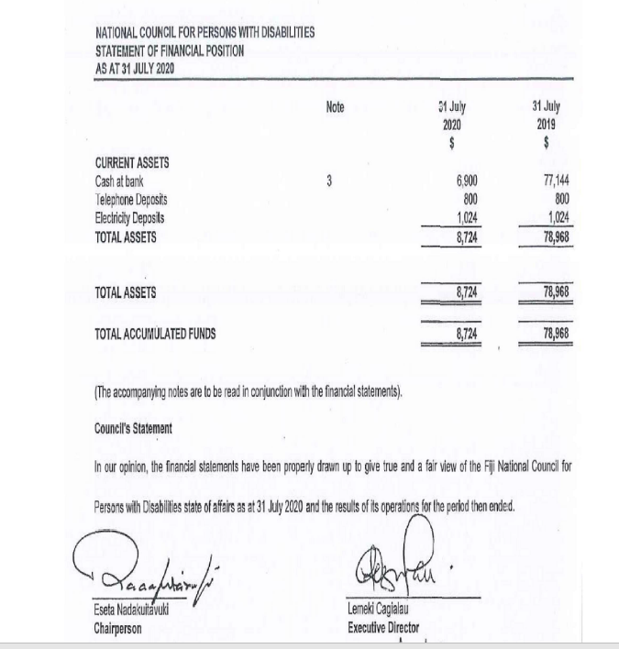

5. Financial Overview
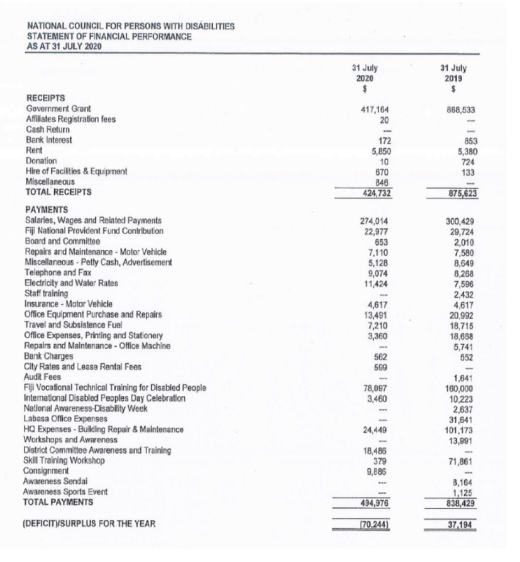

5. Financial Overview

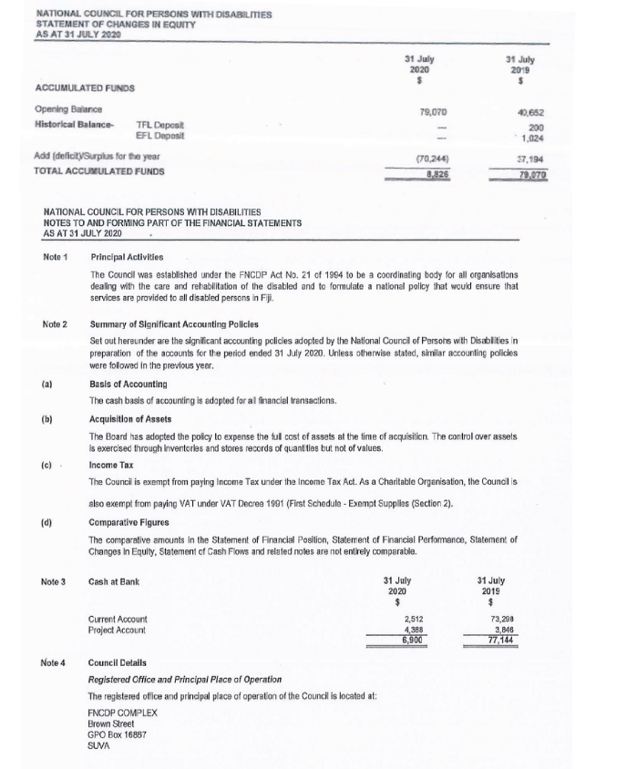

Conclusion

In conclusion, the National Council for Persons with Disabilities (NCPD) faced formidable challenges during the financial year of August 2019 to July 2020, marked by the unprecedented impacts of the global pandemic and other unforeseen obstacles. Despite these hurdles, the Council demonstrated resilience and determination, successfully navigating the uncertainties through strategic planning and collaborative efforts.

Contact Us
03 Brown St., Toorak, Suva
+679-331-9045 www.ncpdfiji.org secretariat@ncpdfiji.org fncdp@connect.com.fi

